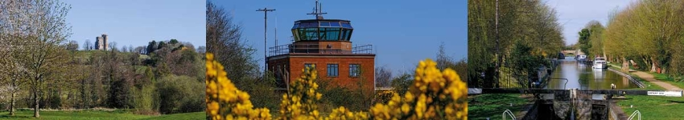

Council Report for February 2026

Written by your local Conservative team to keep you up to date.

Cllr Dennis Benneyworth

Hungerford and Kintbury Ward

West Berkshire Council

Council
Council met on 26th February to discuss:
- The Budget
  - Medium-Term Financial Strategy: Financial Years 2026-2030 (C4678)
  - Treasury Management: Investment and Borrowing Strategy (C4679)
  - Capital Strategy and Supporting Programme: Financial Years 2026/27 - 2029/30 (C4681)
  - Financial Year 2026/27: Revenue Budget (C4680)
Papers and a recording of the meeting can be found here.
The next meeting is on 26th March.

Executive
Executive met on 12th February to discuss:
- The Budget
  - Medium-Term Financial Strategy: Financial Years 2026-2030 (C4678)
  - Treasury Management: Investment and Borrowing Strategy (C4679)
  - Capital Strategy and Supporting Programme: Financial Years 2026/27 - 2029/30 (C4681)
  - Financial Year 2026/27: Revenue Budget (C4680)
- 2025/26 Q3 Financial Performance Report (EX4676)
- Contract for Award Under Delegated Authority from Executive (EX4751)
- 2025/26 Performance Report Q2 (EX4710)
- Expansion, remodelling and development of the SEND (McKee) Resource Unit (Phase 1) at Westwood Farm Schools Federation (EX4766)
Papers and a recording of the meeting can be found here.
The next meeting is on 19th March.

Ridgeway

Consultation now open
A consultation on options for local government reorganisation across Oxfordshire and West Berkshire has been launched by the Government. The last time a change of this scale happened was over 50 years ago so this decision will have a significant impact to everyone in the district for many years.
With councils helping drive the local economy WBC want to tell residents more about the proposals and how residents can have their say here.

What is changing?
The move is in response to a government invitation following its announcement in December 2024 to end two-tier authorities like those in Oxfordshire. As part of the shake-up of local councils, the government has also indicated all unitary authorities will need to serve around 500,000 residents or more, which will require West Berkshire Council - which covers around 170,000 people - to merge with neighbouring councils.
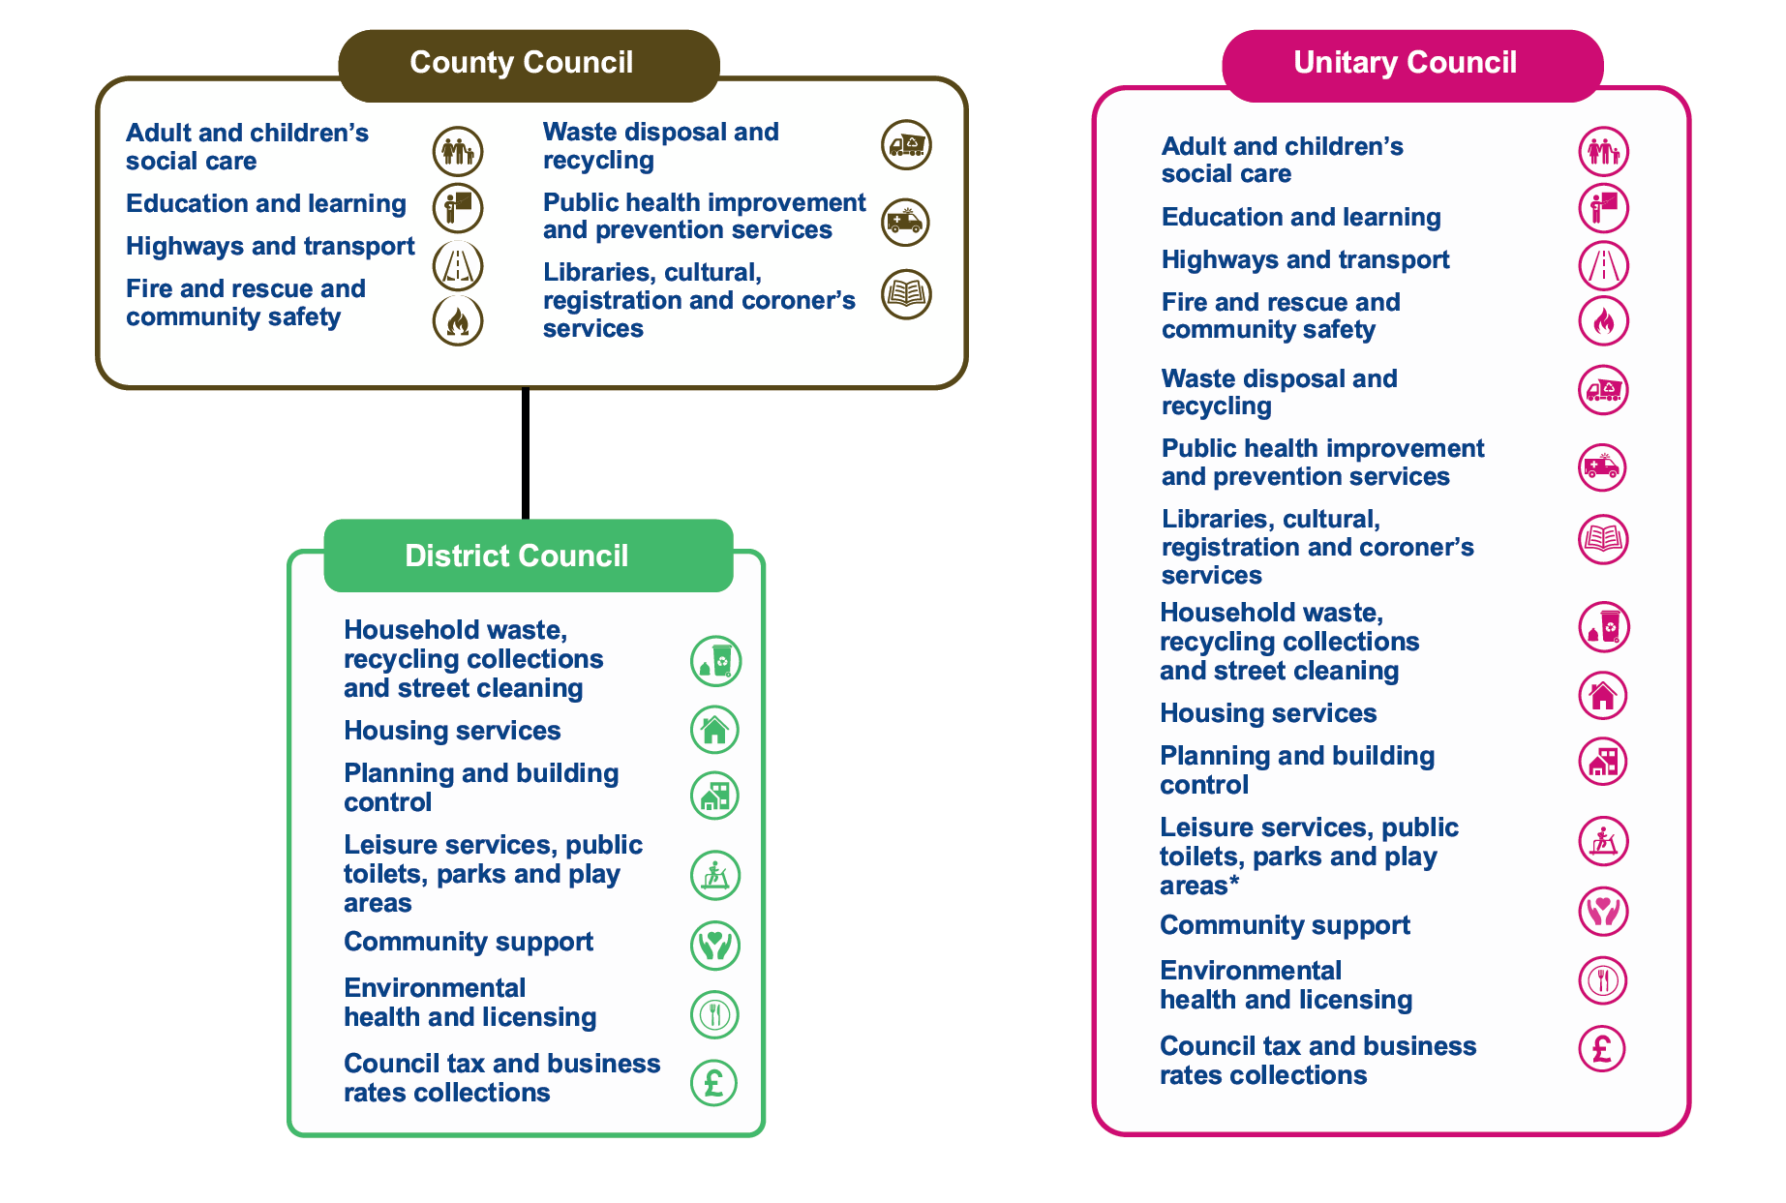

What are the proposals?
The government asked the existing councils to develop proposals for them to consider. There were three proposals submitted to government:
- A single county unitary that covers all of Oxfordshire.
- Two unitary councils that cover Oxfordshire and West Berkshire. One covering the existing council areas of Cherwell, Oxford City and West Oxfordshire. One covering the existing council areas of South Oxfordshire, Vale of White Horse and West Berkshire.
- Three unitary councils that cover Oxfordshire and West Berkshire. One covering the existing Oxford City council area but with expanded boundaries. One covering the remaining existing council areas of Cherwell and West Oxfordshire. One covering the remaining existing council areas of South Oxfordshire, Vale of White Horse and West Berkshire.

Why is this important to businesses in West Berkshire?
Councils have a significant impact on local businesses from strategic work like driving economic growth and housing growth through to provide support to individual businesses and managing town centres. The choice made by the government could impact all of these services for decades to come and so making the right decision for West Berkshire businesses is important.

What do the current councils think is the best option?
Cherwell, South Oxfordshire, Vale of White Horse, West Berkshire and West Oxfordshire overwhelmingly support the two unitary option. 142 out of 158 councillors in attendance at those councils voted to support submitting the two unitary proposal including councillors from all political parties.
Oxfordshire County Council support their single unitary proposal and Oxford City Council support their three unitary proposal.

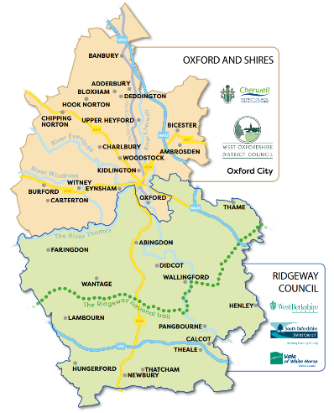
Why does WBC support the two unitary option?
WBC believes that the two unitary proposal is the only one that will deliver improvements to council services, will be financially sustainable, will be responsive to communities and will deliver economic growth.
WBC believe this about creating councils of the right size – not too big that they are distant and ineffective, not too small that they aren’t financially viable. When councillors considered the proposals they felt the two unitary was the one that best met the government criteria and would deliver the best outcomes for West Berkshire businesses.

Want to find out more?
Each proposal has its own website with more information:
- One Council - Oxford County Council
- Two Councils - West Berkshire, Vale of the White Horse, South Oxford, Cherwell District Council, West Oxford District Council.
- Three Councils - Oxford City Council

Education

Falkland Primary School construction work progressing well
Work at Falkland Primary School is continuing at a good pace, despite some disruption from the weather. Since November, persistent rain has caused around three weeks of delay, but good progress has still been made.
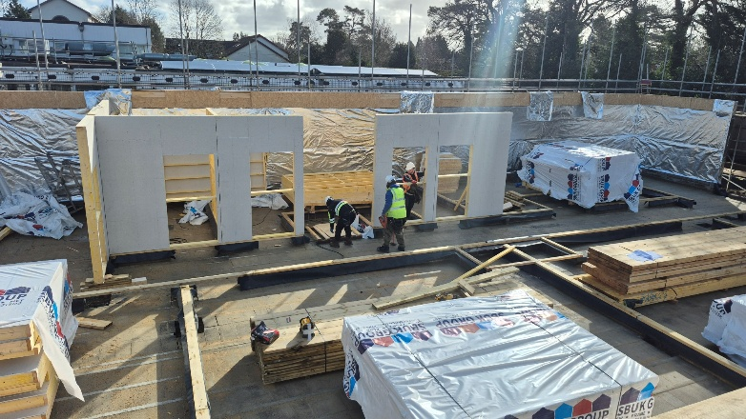
The foundations are now complete, along with the base floor and timber frame. This means the building is really starting to take shape, and you can now walk through it and see how the rooms will be laid out.
Over the next few weeks, steel columns will be put in place, the roof covering will begin, and work will start on the internal floors and staircase.
To help make up for time lost to the rain and keep things on track, there will be some limited weekend working. This will help ensure the building is finished and ready for people to move in before the Autumn Term starts in September.

Elections

Postal Voting Update
Residents who were recently asked to re-apply for their postal vote will shortly receive a letter or email confirming that their previous arrangement has now ended. This follows a letter which was sent in June last year and an email in December.
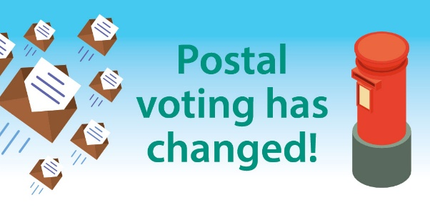
As part of national changes designed to help prevent voter fraud, postal votes now last for a maximum of three years. If they missed the earlier correspondence, there’s no need to worry - applying again is quick and straightforward. Residents can re-apply online where you’ll also find a downloadable application form.
If residents prefer a paper form or would like help, the Electoral Services team is on hand. They can email vote@westberks.gov.uk or call 01635 516464 for assistance.

Community

Community Champions 2026
WBC have announced the winners of the Community Champion Awards 2025!
- Volunteer of the Year: Mike Karasinski
  - Highly Commended: Sue Bennett and David Hamilton
- Community Group of the Year: Cold Ash Countryside Volunteers
  - Highly Commended: Carebus Community Transport and Bradfield Village Hall and Associated Communities
- Lifetime Achievement Award: Tim Barton
  - Highly Commended: Robert Wyatt
The judges were very impressed with the quality of the nominations. Congratulations to all the nominees and thank you to everyone who nominated them.

Easter Holidays Activities and Food programme
The Holidays Activities and Food (HAF) programme offers free holiday club places for children and young people eligible for free school meals. Bookings for Easter went live 25th February on the Holiday Activities portal.
The activity sessions are run during school holidays at no cost to parents, and include:
- Sports, music, arts and crafts
- Outdoor and indoor play, gaming and other exciting opportunities to learn and develop skills
- A nutritious meal each day
- Nutritional resources to keep
- Fun workshops and visits at selected venues
To find out if a child is eligible, please contact their school or WBC’s HAF Coordinator.

Thatcham’s new community hub
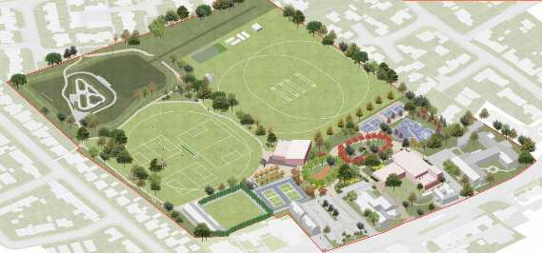
Residents are invited to help shape plans for a possible new community hub at Brownsfield Road in Thatcham. Following feedback from the 2023 Thatcham Town Centre Strategy, West Berkshire Council and Thatcham Town Council are exploring how this important local facility could be developed to better serve the community.

There will be an informal drop-in session at Thatcham Library on Saturday 28th February (12.30pm–2.00pm). Residents can view early ideas, ask questions, and share their vi ews.

They can also take part in the survey online or by emailing economicdevelopment@westberks.gov.uk by 10th March 2026. Any ideas will help shape what happens next.

History Day Out

Residents can immerse themselves in history with a day out in the 17th Century at Shaw House with The Earl Rivers Regiment Muster (Members of The Sealed Knot) on Saturday 7th March, 11am – 4pm.
Witness re-enactors training to use swords, muskets and pikes and visit some of the tradesmen and civilians who accompanied the armies. There will be Living History demonstrations inside Shaw House plus a guided tour of the Dressed for Battle exhibition. Meet Jacques le Roux for a brief talk about the Littlecote arms and armour from 12 to 12.30pm in the First Floor Exhibition Rooms. The day is free with no need to book.

Current Consultations
- Draft Planning Enforcement Plan (June 2025) – Closes 9th March 2026
- Help shape Thatcham's proposed new Community Hub – Closes 10th March 2026
- Proposals for local government reorganisation in Oxfordshire and West Berkshire – 26th March 2026

Parish Matters

Members’ Bids

Fresh round pending
There are indications that a new round of Members’ Bids will open early in the new financial year. Although the maximum amount for which an individual member can bid has been reduced to £4,000 (from £5,000) your ward members can potentially pool this money and bid for up to £12,000 so thinking caps on!

Report a Problem

Get involved
The winter weather has taken its toll on our District’s roads and potholes abound. Please make use of WBC’s Report a Problem facility on the website, it is a really simple and effective way of getting something done. Simply hit ‘View More Services’ link on the WBC home page and ‘Report a Problem’ is the very first option to come up.
There you can report not just potholes but all manner of problems: flooding, trees, dog fouling and many others.

