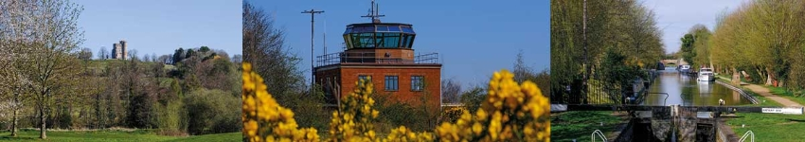

Council Report for January 2026

Written by your local Conservative team to keep you up to date.

Cllr Dennis Benneyworth

Hungerford and Kintbury Ward

West Berkshire Council

Council
Council met on 29th January to discuss:
- Requisition to the Chairman of Council
Papers and a recording of the meeting can be found here.
The next meeting is on 26th February.

Council’s Financial Troubles
Last year, West Berkshire Council requested Exceptional Financial Support (EFS) to help balance its budget. This was granted, and part of the agreement for the EFS was for the Charted Institute of Public Finance and Accountancy (CIPFA) to investigate the Council’s spending.

The CIPFA report was damning, and strongly criticised the Liberal Democrat administration’s financial management. This report’s findings were rejected by the Leader and Executive.

This year, the Council is still in difficulties and, having rejected the findings, will likely need to ask for another bailout from HM Government.

At the Council meeting on 29th January, the Liberal Democrats proposed a motion to ask the Liberal Democrat Leader to write a letter requesting help, but in doing so continued to ignore the CIPFA findings and blamed HM Government for the mess they are in.

The Conservative group chose not to attend this meeting. Antagonising HM Government when another bailout is needed seems a silly idea, not to mention that the Leader does not need permission from Council to write a letter asking for help – which comes at an additional cost to the taxypayer.

Read more here: https://www.newburytoday.co.uk/news/tories-to-boycott-west-berkshire-council-budget-meeting-9450864/ and https://www.newburytoday.co.uk/news/council-in-cash-meltdown-as-redundancies-are-on-the-agenda-9451022/

Executive
Executive met on 29th January to discuss:
- Potential Redundancies - Establishment Changes
Papers and a recording of the meeting can be found here.
The next meeting is on 12th February.

Communities

Holocaust Memorial Day
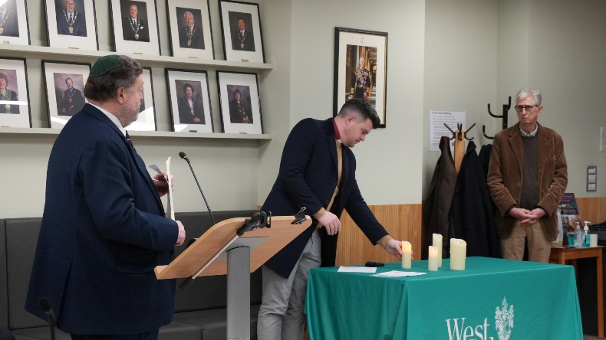
WBC recently came together for Holocaust Memorial Day to commemorate the victims of the holocaust and those persecuted in more recent genocides.

This year's theme is ‘Bridging Generations’, a reminder that remembrance doesn’t end with the survivors, it lives on through their children, grandchildren and through everyone.

WBC marked the day with a candle lighting ceremony led by Rabbi Zvi Solomans and heard the poem ‘We remember them’ read together by children from Winchcombe School and residents of Winchcombe Care Home.

Pension Credit
Residents may have received a letter about Pension Credit. It’s real, and it could help.
WBC have written to some residents we believe could be eligible for Pension Credit, a benefit that tops up income for people over State Pension age.
Residents can call the Pension Credit claim line: 0800 99 1234 or WBC on 01635 551111 to confirm the letter and help find support.
Pension Credit can unlock other support (like free TV licence for over-75s, help with NHS costs and more), so please do check.

Libraries Providing Value
A groundbreaking new report from national charity Libraries Connected shows that public libraries in West Berkshire deliver over £12,000 in value each year by supporting mental health and wellbeing through the provision of volunteering opportunities, particularly among older people.

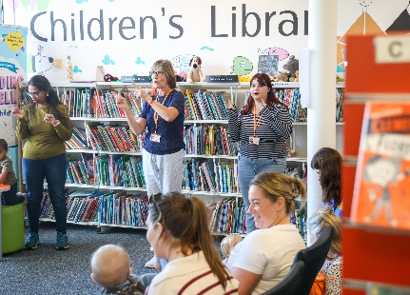
Data was collected over 12 weeks in summer 2025 from West Berkshire and eleven other South East library services. Using Treasury-approved methods, the team calculated the monetary value of the activities, including NHS savings, productivity gains and the personal value placed on improved wellbeing.

The report shows how libraries help to reduce pressure on health and social care services by offering early, low-cost support in the community, reducing isolation and boosting life satisfaction.

The researchers point out that these figures are conservative estimates, and the true value is likely to be much greater.

Newbury Wharf and Peace Garden
We said a temporary goodbye to a familiar face on the Wharf. The historic goods crane, part of Newbury’s industrial heritage, has been carefully removed so specialists can fully refurbish it before its return this summer.
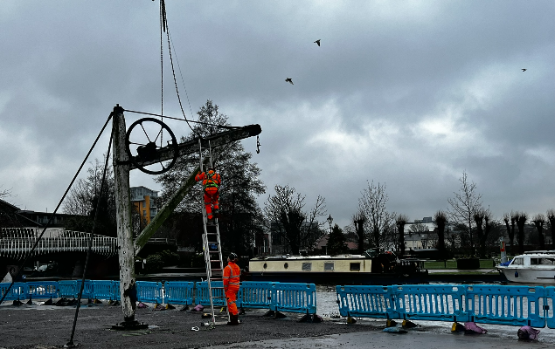
Work to complete the Peace Garden and improve access to Newbury's Wharf is moving into its next phase this month, marking another step in delivering the vision set out in the Newbury Town Centre Masterplan.

These urgent works are crucial to safeguarding the Wharf and will support future enhancements for walking, wheeling and cycling along the waterfront. While this activity is underway, some areas of the Peace Garden will need to be closed temporarily to allow the work to be carried out safely.

Environment and Energy

Calcot Park Golf Course felling
Essential tree works are taking place across Calcot Park Golf Course. Diseased ash trees, particularly in Curtis Wood, need to be removed as they pose a risk to nearby roads, properties, and public safety.
Winter is the safest and most suitable time to carry out this work, as this will support the long-term health of the woodland. Restocking with mixed native broadleaves species is due to occur which will help boost biodiversity over time.
Elsewhere, selective thinning will be carried out under licence from the Forestry Commission - a standard forestry practice that removes poorer quality trees to allow healthier ones, including important veteran trees, to thrive. A small number of dead trees near New Lane Hill will also be felled but replaced.
This is a historically rich landscape, and it is hoped the works will enhance its character for the future.

Bin Lorry Fire
Recently, an incident occurred in Leckhampstead where a bin lorry caught fire due to lithium-ion batteries being placed in a household waste bin. These batteries ignited whilst in the back of our collection vehicle, and posed a serious risk to collection crews, vehicles, and the public.
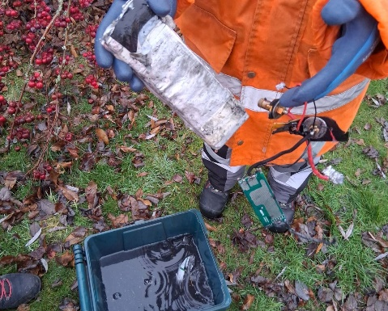
Luckily this time no-one was injured thanks to the swift action of our collection crews and emergency services. The crew ejected the load so that it could be safely extinguished.
Key points:
- Never put batteries in general waste or recycling containers
- Lithium-ion batteries from devices like e-cigarettes, laptops, and power tools, need to be taken to a household waste recycling centre for disposal
WBC collect smaller household batteries if placed in a clear bag on top of your black wheelie bin on collection day

Important information for residents using RTS electricity meters
Radio Teleswitch Service (RTS) meters are being phased out across the UK and replaced with smart meters.
RTS meters are older electricity meters typically used in:
- Homes without gas
- Properties using storage heaters
- Dual-tariff electricity (cheaper overnight rates)
If the RTS meter is not upgraded, residents could lose access to heating or hot water when the signal is switched off.
Energy suppliers will contact affected households directly. Please encourage them to book an installation when notified and contact your council if help is needed checking a message is genuine.
Berkshire councils and the Berkshire Digital Infrastructure Group (DIG) are working together to support residents and reduce disruption.

Public Protection

Underage Sale Test Purchases
Residents aged 15-16 looking for a unique volunteering opportunity to strengthen their CV are being invited by the Public Protection Partnership (PPP) to join its underage sales test purchasing programme, an important initiative that helps protect children and young people from illegal access to age-restricted products.
This programme supports PPP’s work to ensure local businesses follow the law when selling items such as alcohol, tobacco, vapes, knives, fireworks, solvents, and other restricted goods. Volunteering not only enhances your CV but can count towards community service requirements for the Duke of Edinburgh Award and similar schemes. PPP can also provide references to support job, college, or university applications.
Test purchasing involves a volunteer attempting to buy an age-restricted item while supervised by trained PPP officers. Operations take place out of school hours and are fully risk-assessed, with volunteers safeguarded throughout. Full training is provided and volunteers may withdraw at any time.
To apply, please contact Amie.Norkett1@westberks.gov.uk or call on 01635 519930 for an informal chat about the scheme.

Health

New chickenpox protection for children
The NHS has added chickenpox to routine childhood vaccinations through the new MMRV jab (measles, mumps, rubella, and varicella).

Children will be invited by their GP for two doses at age 12 months and 18 months. This change will help to prevent serious illness in childhood and later life.

Look out for your GP’s invitation and make sure your child gets both doses.

Education

Bikeability
WBC are running three Bikeability training courses during February half-term for children aged 10 and above on:
- Tuesday 17th February, Level 3 at Kennet Leisure Centre, Stoney Lane, Thatcham, RG19 4LJ
- Wednesday 18th February, Level 1 and 2 combined course at Kennet Leisure Centre
- Thursday 19th February, Level 3 at Kennet Leisure Centre
All courses are run by DBS checked, fully-qualified Bikeability instructors and cost £25 per course. The child’s bike must be fully road-worthy and the right size. The instructors have the right to refuse training if the bike is deemed unsafe.
More information and how to book is available here.

32 new SEND places at Castle School
The expansion of The Castle School in Newbury is now nearing completion. This is a major milestone in ongoing investment in high quality learning environments for children and young people with Special Educational Needs and Disabilities (SEND).

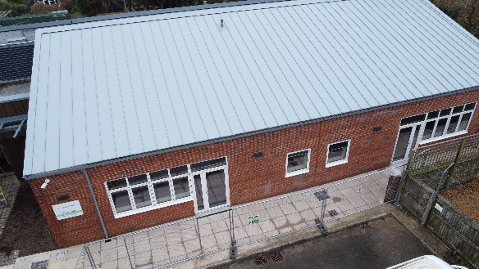
The brand-new Barbury House, named after an Iron Age hillfort in Wiltshire called Barbury Castle, will provide 32 vital SEND places for pupils aged 2 to 19 with complex needs. This expansion not only increases capacity but also enhances the school’s specialist offer, with thoughtfully designed breakout spaces and group rooms to better support tailored learning, wellbeing, and care.

By creating more SEND places locally, the new building will also deliver significant financial benefits. Each placement at Barbury House is estimated to save around £80,000 per year compared to an out of district alternative, ensuring that more West Berkshire children can receive the support they need close to home.

Current Consultations
Draft Planning Enforcement Plan (June 2025) – closes 9th March
Proposed development of a Resource Base at Victoria Park Nursery School, Newbury – closes 25th February

Parish Matters

Report a Problem

Potholes
I make no apology for sounding like a stuck record but please let residents know about the council’s Report a Problem facility on the website. The winter has taken its usual toll on our district’s roads with the inevitable proliferation of potholes. It is possible to accurately report the pothole(s) and to upload photographs.

