

# Council Report for November 2024

### Written by your local Conservative team to keep you up to date.

### Cllr Dennis Benneyworth

### Hungerford and Kintbury Ward

## West Berkshire Council

#### Council

Council met on 28th November to discuss:

* Proposed Main Modifications to the West Berkshire Local Plan Review (LPR) 2022-2039
* Newbury Town Centre Boundary Review and Conservation Area Appraisal
* Youth Justice Plan
* Adoption of the Revised Statement of Licensing Policy Principles Under S.349 of the Gambling Act 2005
* Timetable of Council Meetings 2024/25

Papers and a recording of the meeting can be found [here](https://decisionmaking.westberks.gov.uk/ieListMeetings.aspx?CId=116&Year=0).

The next meeting is on 13th February.

#### Executive

Executive met on 7th November to discuss:

* Wraparound Care Project (EX4578)
* Provision of Care for the Elderly at Two West Berkshire Care Homes Including Dementia and Nursing (EX4529)
* Medium Term Financial Strategy and Revenue Budget 2025-26 planning (EX4593)

Papers and a recording of the meeting can be found [here](https://decisionmaking.westberks.gov.uk/ieListMeetings.aspx?CId=117&Year=0).

There was a subsequent meeting was on 12 December; update to follow.

##### Interim Chief Executive appointed to West Berkshire Council

Joseph Holmes has been appointed Interim Chief Executive of West Berkshire Council.

Joseph is currently the Council's Executive Director (Resources). He first joined West Berkshire Council in 2008 as Chief Accountant and remained in the post for five years before moving on to senior roles at Slough Borough Council and Winchester Council. Joseph returned to West Berkshire Council in 2019 to the Executive Director role which has included overseeing the Council's financial performance during a period when local authorities have been under significant financial pressures.

Speaking about the appointment, Joseph Holmes said:

"I am excited to move into the role of Chief Executive over the coming months and to lead the Council that I started my Local Government career at. We have a dedicated and skilled staff and it is a privilege to serve the district through working with colleagues, members and partner organisations to continue to improve our services for residents."

Recruitment of a permanent Chief Executive will begin next year.

#### Public Safety

##### Keep the Lights on

The Police and Crime Commissioner has criticised plans by the Lib Dem-run West Berkshire Council to cut street lighting across the district which pose a risk to both public safety and public confidence.

Matthew Barber has written to Leader of West Berkshire Council objecting to proposals to switch off street lights in residential areas in the district.

The plans form part of the council’s budget consultation and would see most areas becoming completely dark after midnight.

Charities and women’s safety campaigners have already hit out at similar plans elsewhere, concerned about the safety and confidence of women.

In the letter to West Berkshire Council, Matthew Barber reiterates the challenges made to Oxfordshire County Council earlier this month saying: “Badly lit streets can exacerbate both the risk of crime and the fear of crime.”

“Thames Valley Police has been leading the way nationally in the work to protect women, particularly in the night time economy, with operations such as Project Vigilant. The unilateral dimming or switching off of street lighting may jeopardise not just the confidence that has been built up, but also the safety of women in the county”

Residents can sign the petition online at - <https://matthewbarber.co.uk/keepthelightson>

And respond to the consultation here: [Budget Proposals 2025/26: Turn off streetlights in residential roads between midnight and 5am](https://www.westberks.gov.uk/bp2526-streetlights) – Closes 23rd December 2024

##### Policing Budget Consultation

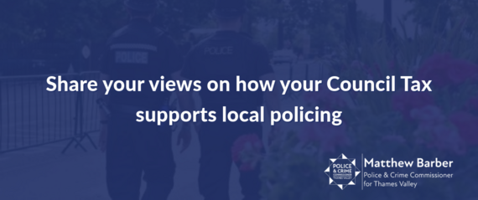Thames Valley Police and Crime Commissioner, Matthew Barber, is asking residents to share views on which areas they would like the policing element of council tax to be focused in the 2025/26 budget.

The Police and Crime Commissioner is due to set the 2025/26 policing budget by the end of January 2025. The allocation of central government funding for forces is expected to be received in December.

The deadline for sharing your views is 12pm on 3rd January - <https://www.thamesvalley-pcc.gov.uk/get-involved/survey/>

##### Staying warm safely in your home this winter

The Public Protection Partnership recently held events where they tested electric blankets and portable heaters. Just under half of the electric blankets tested failed. The two most common reasons for failures were the age of the blanket and damage arising from the ways the blankets are stored. They should be stored flat, rolled up or loosely folded to prevent damaging the internal wiring and should be replaced at least every 10 years. Faulty blankets can cause injury or fires.

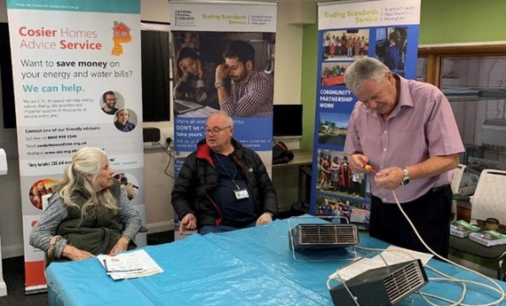Check electric blankets regularly for signs of wear and tear including scorch marks, fraying fabric, exposed elements, creasing, worn flex, loose connections or an old BEAB safety mark.

Portable heaters were also tested and 14% failed. Heaters cause around three fires a day in England. They should be kept away from furniture and curtains and should not be used for drying clothes.

Old hot water bottles can break and cause serious burns. They should also be checked regularly for signs of wear and tear. The flower symbol found on hot water bottles indicates exactly when it was made. The number in the middle is the year it was made, the flower segments represent the 12 months of the year and the dots inside represent the number of weeks. They should be changed every two years.

#### Waste

##### New designs for waste collection vehicles

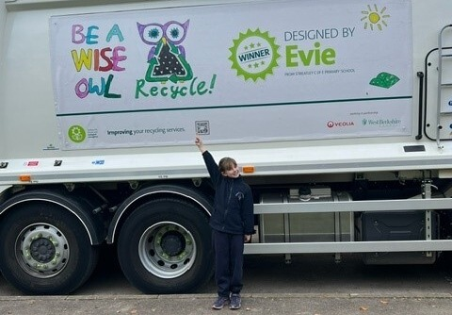During the summer term WBC launched a competition with schools to come up with innovative designs for waste vehicles. Over 500 entries were received for the Recycle Design competition and it was a tough decision for the judges to narrow down the entries and pick the winners.

The winners were Evie with her ‘Be a wise owl’ design and Anish with his ‘Save Earth’ design! A huge well done to both Evie and Anish who were recently visited at their schools to present them with their certificates and unveil their winning designs on the collection vehicles.

A big thank you to everyone who took part, residents will enjoy seeing the designs on the vehicles around the district when making waste and recycling collections.

##### Fuelling a greener future

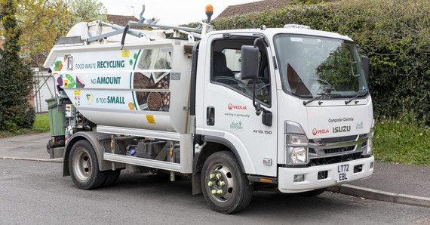All WBC waste collection vehicles that are used to collect weekly food waste from households, and the delivery vehicle for bins, boxes and bags across the district, are now running on Hydrotreated Vegetable Oil (HVO), a cutting-edge renewable diesel.

Made from certified sustainable materials, HVO can replace diesel directly and offers up to a 90% reduction in fossil carbon dioxide emissions, making it significantly better for the environment than regular diesel. This initiative supports the goal to achieve net zero across the district by 2030.

Expanding on the net zero ambition, an electric Refuse Collection Vehicle (eRCV) will also be trialled this autumn to further develop plans for more sustainable services.

##### Go green with the Green Machine

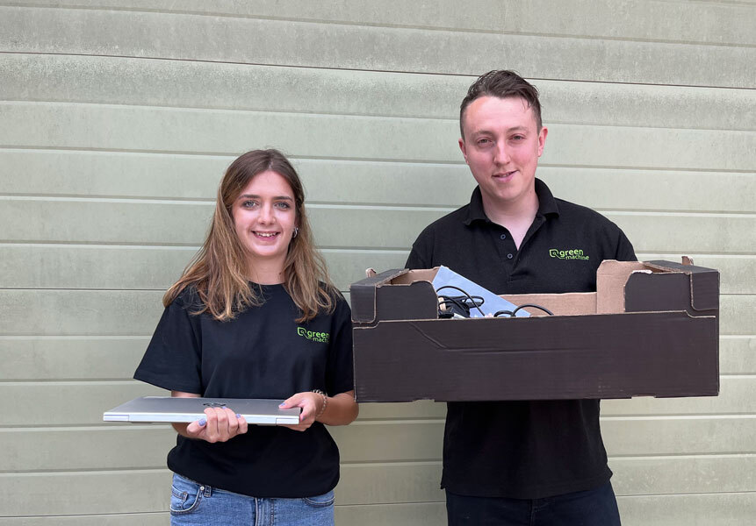Christmas is coming and many people will have a new laptop, tablet, or other electronic device on their list. If Santa delivers on your tech wish list, then your old laptop could be recycled, refurbished, and potentially used for good by a school or community project.

WBC have been recycling old computers through Green Machine Computers for some time. They collect all redundant ICT equipment and refurbish 50% of what is collected. Around half of this is distributed to schools and charities free of charge.

They can do this with your old tech items too! Residents who have devices they want to recycle responsibly and potentially benefit schools and other worthy causes, can be dropped off at the Newbury Community Furniture Project at Hambridge Road Industrial Estate, Bone Lane, Newbury RG14 5SS.

Between Wednesday 20th November and Saturday 21st December there will be an added Christmas treat as the Green Machine team will be hosting Pop Up shops there on Wednesdays, Thursdays, Fridays and Saturdays between 9am and 5pm selling refurbished laptops as well as some smaller computer accessories such as keyboards and cables.

#### Culture and Leisure

##### Kennet Leisure Centre is getting an upgrade!

There will be a major refurbishment project starting this December to enhance the health and fitness experience for residents of all ages and abilities at Kennet Leisure Centre!

The revamp is part of a comprehensive programme of leisure facility improvements around the district which include the wonderful Northcroft Lido and a refurbishment of Northcroft Leisure Centre that will be complete early next year. Work is also underway on a new modular exercise studio at Hungerford Leisure Centre.

Key upgrades include:

* Complete overhaul of the gym with redecoration, new flooring and state-of-the-art equipment.
* 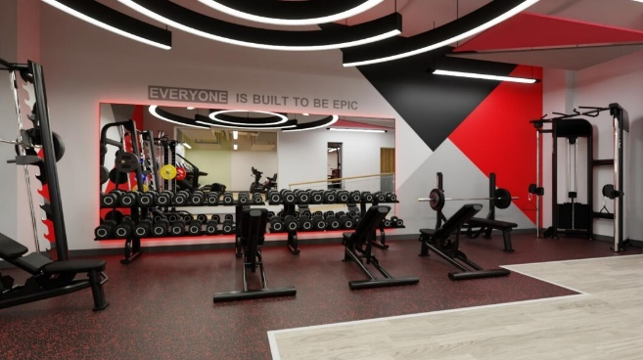Modernisation of the indoor cycling room and studio spaces.
* Full revamp of the squash court scheduled for January.

The gym will be closed for two weeks from Monday 2nd December. During this time, members can use Northcroft Leisure Centre’s facilities. Classes will continue with minimal disruption.

Stay tuned for updates on the refurbishment progress, or contact the leisure centre team for the latest information.

##### Children’s Magic Show

It’s show time at [Shaw House](https://url.uk.m.mimecastprotect.com/s/05lvC0Vp3HgK9W1SwgTmH98PeU?domain=links-1.govdelivery.com) on Sunday 15th December, at 11am, 12.30pm and 2pm! Featuring Mr Muddle the charming, if muddlesome magician, who captivates and amazes children with his comical slapstick magic and laugh-out-loud antics! Each child ticket (£8) includes one free adult. [Book early](https://url.uk.m.mimecastprotect.com/s/FGiyCgLKXiwrjWMfNzUgH4l7Zl?domain=links-1.govdelivery.com) to avoid disappointment.

##### Movie in the Hall: A Christmas Carol

Head to [Shaw House](https://url.uk.m.mimecastprotect.com/s/_mDzCjqMJtG2wJWfW3c7HmkixD?domain=links-1.govdelivery.com) on Monday 23rd December for an animated retelling of Charles Dickens' classic novel about a Victorian-era miser taken on a journey of self-redemption, courtesy of several mysterious Christmas apparitions.

The café will be open serving themed cinema sweets and treats. Feel free to come along in fancy dress!

Doors open at 10am, film starts at 10.30am. [Book your tickets here](https://url.uk.m.mimecastprotect.com/s/rcvECkZKMiX7R0xS2pt8HGLq9B?domain=links-1.govdelivery.com) (Adults £5, Child £3)

##### Messy Museum Morning

Tree-ific festive fun at [West Berkshire Museum](https://url.uk.m.mimecastprotect.com/s/BkLnCl5L6fPy3KQcGOhNHzMmjv?domain=links-1.govdelivery.com) on Friday 20th December, 10am - 1pm! Decorate a ceramic Christmas tree hanging decoration with porcelain pens and glitter and take it home to put on the tree. This is a drop-in session which costs £2.50 per child.

#### Transport

##### Free Bus Travel

To help get ready for a jolly holiday season, WBC are once again offering free bus travel in West Berkshire!

On two Saturdays, residents can travel all day, any time, completely FREE (do check the timetables) within West Berkshire, providing an excellent chance to explore and enjoy various seasonal events and activities in the run up to Christmas!

* Saturday 14th December 2024
* Saturday 21st December 2024

But that's not all! Free travel extends beyond West Berkshire to neighbouring areas such as Reading, Didcot, Basingstoke, and Swindon. If the journey is started in West Berkshire, the return journey is also FREE! There is a need to request a return ticket from the driver when boarding to take advantage of this offer.

Information available about the free bus travel offer at the following link [https://www.westberks.gov.uk/transportchanges](https://url.uk.m.mimecastprotect.com/s/-1t0CzK5lfw04RWC43T2H9rQf5?domain=links-1.govdelivery.com).

The Free Bus Travel at Christmas has been made possible by funding from HM Government, given to West Berkshire Council after submission of the [Bus Service Improvement Plan (BSIP).](https://url.uk.m.mimecastprotect.com/s/LiXdCAPoOUlvE9pSGzFDHGh81i?domain=links-1.govdelivery.com)

##### West Berkshire gritters ready to tackle winter roads

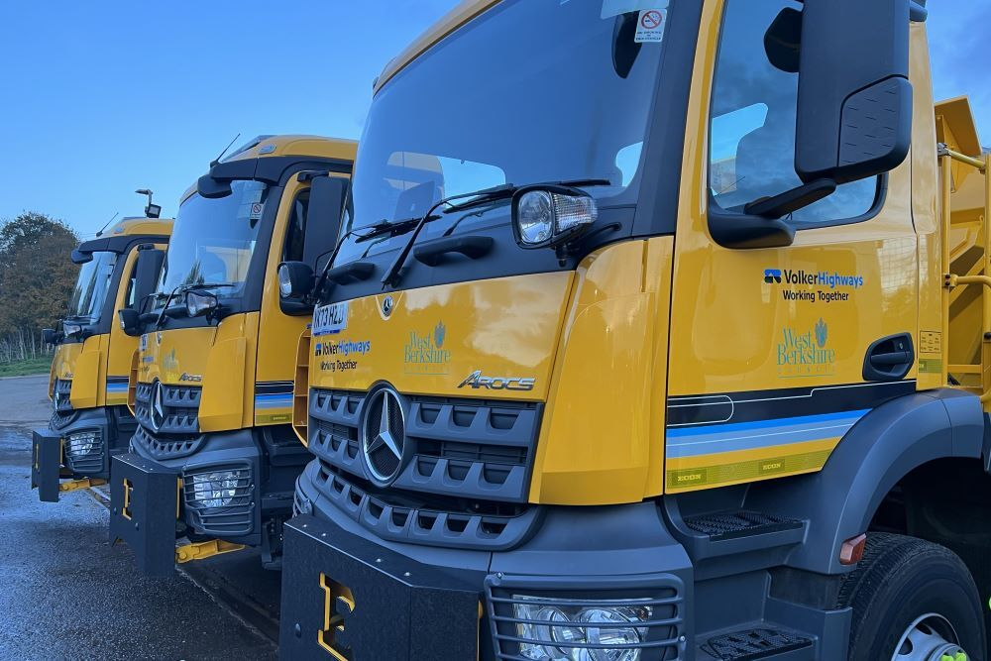Usain Salt, Sir Gritalot, Melty Micky, and the rest of West Berkshire’s nine-strong gritter fleet are prepped and ready for action to gear up for winter.

Test runs have been successfully completed to ensure all equipment is in top condition, and with 2,500 tonnes of salt stocked at the depot, teams are fully prepared for whatever the weather brings.

Last winter, gritters covered 11,515 miles, spreading over 2,600 tonnes of salt to keep the district’s roads safe. Roads are salted when temperatures are near freezing, typically before the morning or evening rush hours, as these are peak times for frost and ice. Real-time data from weather stations across West Berkshire helps forecast and deploy gritters efficiently, treating the most critical routes first.

Don’t forget - over 446 salt bins, owned and maintained by Parish/Town Councils, are available across the district for residents to use on public roads and paths during icy conditions. The salt is not to be used on private properties i.e. for driveways or private footpaths. WBC only treat footways, including pavements and cycleways, in times of persistent ice or snow.

#### Current Consultations

[Budget Proposals 2025/26: Remove Downland Sports Centre from the Leisure Management Contract](https://www.westberks.gov.uk/bp2526-downland-sports-centre) – Closes 23rd December 2024

[Budget Proposals 2025/26: Reduce the number of winter gritting routes](https://www.westberks.gov.uk/bp2526-winter-gritting) – Closes 23rd December 2024

[Budget Proposals 2025/26: Discontinue the Mobile Library Service](https://www.westberks.gov.uk/bp2526-mobile-library) – Closes 23rd December 2024

[Budget Proposals 2025/26: Turn off streetlights in residential roads between midnight and 5am](https://www.westberks.gov.uk/bp2526-streetlights) – Closes 23rd December 2024

[Budget Proposals 2025/26: Create a voluntary charitable contribution (via Council Tax payments) scheme](https://www.westberks.gov.uk/bp2526-voluntary-charitable-contribution) – Closes 23rd December 2024

[Budget Proposals 2025/26: Increase some Adult Social Care (ASC) fees and charges above the rate of inflation](https://www.westberks.gov.uk/bp2526-asc-fees) – Closes 23rd December 2024

[Budget Proposals 2025/26: Cease providing the Adult Respite (ARC) in the Community Service](https://www.westberks.gov.uk/bp2526-adult-respite) – Closes 23rd December 2024

[Budget Proposals 2025/26: Explore options to deliver Adult Social Care (ASC) Resource Centre services through an alternative provider or in a different way](https://www.westberks.gov.uk/bp2526-asc-resource-centres) – Closes 23rd December 2024

[Budget Proposals 2025/26: Remove a proportion of the litter bins and dog waste bins from the Grounds Maintenance Contract](https://www.westberks.gov.uk/bp2526-litter-dog-bins) – Closes 23rd December 2024

[Draft Carers Strategy 2024-2027](https://westberks.gov.uk/draft-carers-strategy) – Closes 17th November 2024

# Parish Matters

#### Member’s Bids

##### January 3rd deadline

Just by way of a gentle reminder, the current round of Member’s Bids is open and the closing date is Friday 3rd January 2025.

Please get in touch with any projects that might fit the bill.

#### Merry Christmas!

I would like to wish all of you hard-working councillors and clerks a very merry Christmas and very much look forward to working with you all in 2025!